**Chapter 1**

# COMPANY PROFILE

## 1.1 A Brief History of Compsoft Technologies

Compsoft Technologies, was incorporated with a goal ”To provide high quality and optimal Technological Solutions to business requirements of our clients”. Every business is a different and has a unique business model and so are the technological requirements. They understand this and hence the solutions provided to these requirements are different as well. They focus on clients requirements and provide them with tailor made technological solutions. They also understand that Reach of their Product to its targeted market or the automation of the existing process into e-client and simple process are the key features that our clients desire from Technological Solution they are looking for and these are the features that we focus on while designing the solutions for their clients.

Sarvamoola Software Services. is a Technology Organization providing solutions for all web design and development, MYSQL, PYTHON Programming, HTML, CSS, ASP.NET and LINQ. Meeting the ever increasing automation requirements, Sarvamoola Software Services. specialize in ERP, Connectivity, SEO Services, Conference Management, effective web promotion and tailor-made software products, designing solutions best suiting clients requirements.

Compsoft Technologies, strive to be the front runner in creativity and innovation in software development through their well-researched expertise and establish it as an out of the box software development company in Bangalore, India. As a software development company, they translate this software development expertise into value for their customers through their professional solutions.

They understand that the best desired output can be achieved only by understanding the clients demand better. Compsoft Technologies work with their clients and help them to defiine their exact solution requirement. Sometimes even they wonder that they have completely redefined their solution or new application requirement during the brainstorming session, and here they position themselves as an IT solutions consulting group comprising of high caliber consultants.

They believe that Technology when used properly can help any business to scale and achieve new heights. It helps Improve its efficiency, profitability, reliability; to put it in one sentence ” Technology helps you to Delight your Customers” and that is what we want to achieve.

**1.2 ABOUT THE COMPANY**

Compsoft Technologies is a Technology Organization providing solutions for all web design and development, MYSQL, PYTHON Programming, HTML, CSS, ASP.NET and LINQ. Meeting the ever increasing automation requirements, Compsoft Technologies specialize in ERP, Connectivity, SEO Services, Conference Management, effective web promotion and tailor-made software products, designing solutions best suiting clients requirements. The organization where they have a right mix of professionals as a stakeholders to help us serve our clients with best of our capability and with at par industry standards. They have young, enthusiastic, passionate and creative Professionals to develop technological innovations in the field of Mobile technologies, Web applications as well as Business and Enterprise solution. Motto of our organization is to “Collaborate with our clients to provide them with best Technological solution hence creating Good Present and Better Future for our client which will bring a cascading a positive effect in their business shape as well”. Providing a Complete suite of technical solutions is not just our tag line, it is Our Vision for Our Clients and for Us, We strive hard to achieve it.

## 1.3 Products of Compsoft Technologies.

**Android Apps**

It is the process by which new applications are created for devices running the Android operating system. Applications are usually developed in Java (and/or Kotlin; or other such option) programming language using the Android software development kit (SDK), but other development environments are also available, some such as Kotlin support the exact same Android APIs (and bytecode), while others such as Go have restricted API access.

The Android software development kit includes a comprehensive set of development tools. These include a debugger, libraries, a handset emulator based on QEMU, documentation, sample code, and tutorials. Currently supported development platforms include computers running Linux (any modern desktop Linux distribution), Mac OS X 10.5.8 or later, and Windows 7 or later. As of March 2015, the SDK is not available on Android itself, but software development is possible by using specialized Android applications.

**Web Application**

It is a client–server computer program in which the client (including the user interface and client- side logic) runs in a web browser. Common web applications include web mail, online

retail sales, online auctions, wikis, instant messaging services and many other functions. web applications use web documents written in a standard format such as HTML and JavaScript, which are supported by a variety of web browsers.

Web applications can be considered as a specific variant of client–server software where the client software is downloaded to the client machine when visiting the relevant web page, using standard procedures such as HTTP. The Client web software updates may happen each time the web page is visited. During the session, the web browser interprets and displays the pages, and acts as the universal client for any web application. The use of web application frameworks can often reduce the number of errors in a program, both by making the code simpler, and by allowing one team to concentrate on the framework while another focuses on a specified use case. In applications which are exposed to constant hacking attempts on the Internet, security- related problems can be caused by errors in the program

**Web design**

It is encompasses many different skills and disciplines in the production and maintenance of websites. The different areas of web design include web graphic design; interface design; authoring, including standardized code and proprietary software; user experience design and search engine optimization. The term web design is normally used to describe the design process relating to the front-end (client side) design of a website including writing mark up. Web design partially overlaps web engineering in the broader scope of web development.

## 1.4 Departments and services offered

Compsoft Technologies plays an essential role as an institute, the level of education, development of student’s skills are based on their trainers. If you do not have a good mentor then you may lag in many things from others and that is why we at Compsoft Technologies gives you the facility of skilled employees so that you do not feel unsecured about the academics. Personality development and academic status are some of those things which lie on mentor’s hands. If you are trained well then you can do well in your future and knowing its importance of Compsoft Technologies always tries to give you the best.

They have a great team of skilled mentors who are always ready to direct their trainees in the best possible way they can and to ensure the skills of mentors we held many skill development programs as well so that each and every mentor can develop their own skills with the demands of the companies so that they can prepare a complete packaged trainee.

## Services provided by Compsoft Technologies.

* Core Java and Advanced Java
* Web services and development
* Dot Net Framework
* Python
* Selenium Testing
* Conference / Event Management Service
* Academic Project Guidance
* On The Job Training
* Software Training

**Chapter 2**

# ROAD MAP TO THE INTERNSHIP PROGRAM

## 2.1 TASK PERFORMED

|  |  |
| --- | --- |
|  | **Week 1 Activities** |
| • | Introduction to the Internship Program |
| • | Selection of Internship Domain and Mini Project |
| • | Introduction to the Python Programming –Part 1 |

|  |  |
| --- | --- |
|  | **Week 2 Activities** |
| • | Python programming including OOPs –Part 2 |
| • | Introduction to Machine Learning |

|  |  |
| --- | --- |
|  | **Week 3 Activities** |
| • | Machine Learning Project Execution Life Cycle |
| • | Analysis of Design Model in Machine learning |
| • | Start the Internship Project |

|  |  |
| --- | --- |
|  | **Week 4 Activities** |
| • | Implementation of Project – Tools : vs code |
| • | Project Code Execution |
| • | Results and Conclusions |
| • | Report Preparation and Submission |
| • | Internship Presentation - PPT |

**Chapter 3**

# ABOUT THE INTERNSHIP

As per the regulations from various universities, we deliver the various levels of internship training and development. The internship duration may be from 4 -8 weeks. We provide solutions to the students that they can upgrade their knowledge and apply, convert it into project development. We have proposed our internship program keeping in focus of present demand of industry standards, so that we can make ready our students to fill the gap between industry academics and value added courses to enhance the skills which helps them to build the strong career in the field of computer science.

An internship during college studies can help to enhance quality of higher education and to improve skills & competencies amongst students. It helps to fill the gap between the theoretical learning at class room and practical application at work place. It is also seen that the student undergoing internships while their 3 years degree course are not able to perform better in their regular exams because of time constraints. On the other hand, Internships also help them to achieve higher professional competencies and excellence in their field of interest and so that they can perform better in their future job with full potential knowledge.

## 3.1 Benefit of Internship

Finding work can be a real challenge, especially if you don't have any experience. Yet to get experience you must first find a job. It is a nasty catch that can be difficult to get around but an internship is a good way to do it. Internships provide work experience opportunities to university students like me, recent graduates and people considering career changes.

Universities encourage students like me to participate in internship programs because they believe that there are many benefits that student’s get in a supervised real life work environment in which they have the opportunity to put theory into practice.

When job opportunities are hard to come by, students increasingly relied on internships to differentiate themselves from their non-participating counterparts. It seems employers are willing to give employment to a job seeker who has a working experience even if it is in the form of internship attachment. The link between internship participation and securing of a job sometimes tends to be taken for granted. Students expected to be provided with full-time employment at the completion of the internship. Many students enroll into degree programs without having a clear understanding of the profession they are getting into. Participation in internship programs gives students a chance to know the profession and a possibility of making a final decision on whether they are in the right career path or not.

## Gain Valuable Work Experience

An internship provides the opportunity to gain hands on work experience that you just cannot get in the classroom. First time job seekers and career changers are not usually desirable candidates, but companies are willing to train them as interns and give them the experience they would need to get a job.

**Networking Opportunities**

Internships are a great way to meet people in your field. Even if you have experience, knowing people never hurts. An internship allows you to meet people who might help you land a job later on and give you the contacts in the industry you are trying to break into. In addition, references from people in the Research field will really add weight to your application.

**Apply Classroom Knowledge**

An internship can be seen as the pinnacle of your undergraduate education and give you the chance to use the skills you have learned in the classroom in a real-world setting. It is a chance to prove the worth of your qualifications and to show that you can perform in the role you has been given.

**Gain Confidence**

Getting experience is a great way to build your confidence. What's more, if you have an impressive resume, you will be more confident in your chances of securing a job. After you have done an internship, if an interviewer asks if you know how to do something, you will not say “um, yes, I think I would be able to do that" but can say “absolutely" and supplement your assertion with examples.

## 3.3 Non-Technical Outcomes

**3.3.1 Personality Development**

Personality development is defined as the relatively enduring patterns of thoughts, feelings, and behaviours that distinguish individuals from one another. The personality is the typical pattern of thinking, feeling, and behaviours that make a person unique. It gives you more confidence.

It makes you look more credible. Despite the saying that you do not judge a book by its cover, people do tend to judge people by their clothing and how it is worn. This does not mean buying expensive clothes. We all know people who look shabby in expensive clothes. There are also people who look great even if their attire is inexpensive.

**3.3.2 Verbal communication**:

Also known as speaking, is an important form of communication in a healthcare facility. Planning and organizing your thoughts is a critical part of verbal communication. This involves thinking about who will receive the message and what you want to convey, making notes before a phone call, having an agenda for a meeting, or researching information you wish to give to someone in advance are all methods you can use to ensure clear communication.

### 3.3.3 Clear

Speak in black-and-white terms to clearly state your message. Allow questions from the recipient of your communication to ensure you are understood.

### 3.3.4 Concise

Do not ramble. Your important message can be lost in then on essential information you include—get to the point.

### 3.3.5 Consistent

Make the message consistent at all times. If you are telling your supervisor about an incident that you have observed, do not change your story to make it more dramatic. Report your findings in a consistent, accurate manner. Do not tell one person what you saw and later change your observations as you re tell the story to another person.

### 3.3.6 Credible

People can tell if your words are insincere make sure your message is real. Do not heap praise on someone just because you want to win their favour. It is important that you mean what you say.

### 3.3.7 Courteous

Words and phrases such as “hello,” “thank you,” “please,” excuse me,” and “I’m sorry” are easy, effective ways to demonstrate respect. Being courteous when you communicate sets the right tone and attitude. Courtesy is mandatory in the workplace, even if you are interacting with someone you dislike. Keep your personal feelings out of your work interactions. Having an open mind during verbal communication is also very important. Making assumptions about what someone is going to say before he or she speaks might cause you to miss the essence of the message.

### 3.3.8 Public speaking

* Be prepared. Practice your presentation several times. Know more about your material than you include in your speech. Use humour, personal stories, and conversation al language if relevant.
* Look at the audience and establish direct eye contact. Smile, develop rapport, and notice if your audience looks like they are following what you are saying or if they look puzzled or confused.
* Relax and slowly count to three before beginning to allow yourself time to calm down. Don’t apologize for being nervous. Realize that people want you to succeed.

### 3.3.9 Time Management

* “Time management” refers to the way that you organize and plan how long you spend on specific activities. It may seem counter-intuitive to dedicate precious time to learning about time management, instead of using it to get on with your work, but the benefits are enormous:
* During internship Communication Challenges Anything that interferes with communication can lead to a misinterpretation of your message. However, various factors can interfere specifically with your ability to communicate verbally with your patients.

## 3.4 About Python Programming

Python is a high-level, interpreted, interactive and object-oriented scripting language..

* Python is interpreted: Python is processed at runtime by the interpreter. You do not need to compile your program before executing it. This is similar to PERL and PHP.
* Python is Interactive: You can actually sit at a Python prompt and interact with the interpreter directly to write your programs.
* Python is Object-Oriented: Python supports Object-Oriented style or technique of programming that encapsulates code within objects.
* Python is a Beginner's Language: Python is a great language for the beginner-level programmers and supports the development of a wide range of applications from simple text processing to WWW browsers to games.

## 3.5 Python Features

* Simple and easy to learn: Python has a simple syntax and easy-to-understand code structure that makes it easy for beginners to learn and use.
* Interpreted language: Python is an interpreted language, which means that it does not require compilation before running the code. This makes the development process faster and more efficient.
* Object-oriented: Python is an object-oriented language that supports the creation of classes and objects, encapsulation, inheritance, and polymorphism.
* Large standard library: Python comes with a large standard library that provides a wide range of modules and functions for performing various tasks, such as networking, database access, GUI programming, and more.

### 3.6 VS Code

Visual Studio Code (VS Code) is a highly versatile, open-source code editor developed by Microsoft. It is designed for building and debugging modern web and cloud applications, offering a balance between the simplicity of a code editor and the power of a full-fledged integrated development environment (IDE). VS Code supports a wide range of programming languages and comes with built-in support for JavaScript, TypeScript, and Node.js, along with rich extensions for other languages like Python, Java, and C++.

Advantages of VS Code

* Cross-Platform Support: Available on Windows, macOS, and Linux, ensuring a consistent development experience across different operating systems.
* Extensibility: Extensive marketplace with thousands of extensions for adding language support, themes, debuggers, and tools to enhance productivity.
* Integrated Git Support: Built-in Git commands and integration make version control seamless and efficient, allowing you to perform all Git operations within the editor.
* Rich Debugging Capabilities: Robust debugging tools that support breakpoints, call stacks, and an interactive console, helping you identify and fix issues quickly.
* IntelliSense: Advanced code completion and syntax highlighting features that provide smart suggestions, parameter info, and quick info, boosting coding efficiency.
* Integrated Terminal: Built-in terminal that allows you to run shell commands and scripts directly within the editor, streamlining the development workflow.
* Customizability: Highly customizable through user settings, key bindings, and workspace settings, enabling you to tailor the editor to your preferences.
* Performance: Lightweight and fast, providing a responsive user experience even with large projects and numerous extensions.

**3.7 Dlib**

Dlib is an open-source C++ library that is widely used for various machine learning and computer vision tasks. Some of its notable features include:

* Face Detection: Dlib provides highly accurate face detection algorithms that can detect faces in images or video streams.
* Facial Landmark Detection: It includes pre-trained models for detecting facial landmarks, such as the position of eyes, nose, and mouth. This is useful for tasks like face alignment and expression analysis.
* Object Detection and Tracking: Dlib offers object detection algorithms, including the popular Histogram of Oriented Gradients (HOG) method, which can be used to detect and track objects in images or videos.
* Machine Learning Algorithms: Dlib provides a variety of machine learning algorithms, such as Support Vector Machines (SVM), k-Nearest Neighbors (k-NN), and Deep Neural Networks (DNN). These algorithms can be used for tasks like classification, regression, and clustering.
* Image Processing: Dlib offers a range of image processing functionalities, including image manipulation, filtering, and feature extraction.

**Chapter 4**

# SYSTEM REQUIREMENTS

The System Requirements Specification document describes all data, functional and behavioural requirements of the software under production or development. A functional requirement document defines the functionality of a system or one of its subsystems. It also depends upon the type of software, expected users and the type of system where the software is used. Nonfunctional requirement is a requirement that specifies criteria that can be used to judge the operation of a system, rather than specific behaviours.

## 4.1 Software Requirements

|  |  |  |
| --- | --- | --- |
| Operating System | - | Windows |
| Simulation Tools | - | Visual Studio Code |
| Python | - | Version 3.9.6 |
| Packages | - | Pyttsx3Speech RecognitionWikipediaPyaudioWeb browser |

## 4.2 Hardware Requirements

|  |  |  |
| --- | --- | --- |
| Processor | - | Intel Pentinum4 |
| RAM | - | 512MB |
| Hardware capacity | - | 80gb |
| Mouse |  |  |
| Microphone |  |  |
| Personal Computer/Laptop |  |  |
| CD-Drive type | - | 52xmax |

**Chapter 5**

# SYSTEM DESIGN

System Design is a process of planning a new business system or replacing an existing system by defining its components or modules to satisfy the specific requirements. Before planning, you need to understand the old system thoroughly and determine how computers can best be used in order to operate efficiently. System analysis is conducted for the purpose of studying a system or its parts in order to identify its objectives. It is a problem-solving technique that improves the system and ensures that all the components of the system work efficiently to accomplish their purpose.

## 5.1 System design Architecture

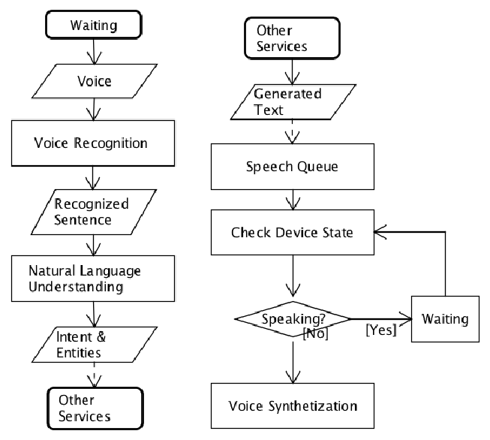

Fig 5.1: speech recognition flow chart

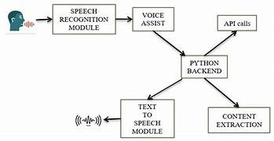

Fig.5.2: Preprocessing of user input

Creating a Speech recognition project typically involves using voice assist and machine learning techniques to listen to commands given by user and reply with the answer. This kind of project is often implemented in the context of blind or visually impaired people who cannot access to things easily.

Here are the key steps to create a drowsiness detection project:

### Define the Project Scope

### **Identify Features:** Weather updates, speech-to-text, playing songs/videos, retrieving Wikipedia information.

* **Choose Platforms:** Decide if it will be a desktop, mobile, or both.
* **Select Technologies:** Determine programming languages, frameworks, and libraries to use.

### Set Up the Development Environment

### **Choose a Programming Language:** For example, Python.

### **Install Necessary Libraries:** Libraries for speech recognition, text-to-speech, API requests, etc.

### Implement Speech Recognition

### **Choose a Speech Recognition Library:** For instance, speech recognition.

### **Set Up Microphone Input:** Configure the system to capture audio input from the user.

### **Convert Speech to Text:** Use the chosen library to translate spoken words into text.

### Implement Text-to-Speech

### **Select a Text-to-Speech Library:** Options include pyttsx3.

### **Configure Output:** Set up the system to convert text responses back into speech.

### Fetch Weather Information

### **Choose a Weather API:** For example, OpenWeatherMap.

### **Make API Requests:** Set up functions to request weather data based on user input.

### **Parse and Present Data**:**** Extract and format the relevant weather information for the user.

### Play Songs or Videos

### **Select a Media Library or API:** For instance, pytube for YouTube videos.

### **Fetch Media:** Set up functions to search for and play media based on user requests.

### **Handle Media Playback:** Ensure the system can play the media files smoothly.

### Retrieve Information from Wikipedia

### **Choose a Wikipedia Library:** For example, wikipedia.

### **Query Wikipedia:** Set up functions to search for and retrieve summaries of Wikipedia articles.

### **Present Information:** Format and present the retrieved information to the user.

### Integrate All Components

### **Create a Main Loop:** Set up a loop to continuously listen for commands.

### **Process Commands:** Use conditional statements to determine which function to call based on user input.

### **Respond Appropriately:** Convert the output back to speech and deliver it to the user.

### Testing and Deployment

### **Test Thoroughly:** Ensure all features work correctly across different scenarios.

### **Package the Application**:**** Prepare the application for distribution on the chosen platform(s).

### **Deploy:** Release the application for use by end-users.

### Improve and Iterate

### **Gather User Feedback:** Collect and analyze feedback to identify areas for improvement.

### **Add New Features**:**** Continuously enhance the virtual assistant by adding new functionalities and improving existing ones.

**Chapter 6**

# IMPLEMENTATION

**Step 1**: Define the Project Scope and Set Up the Environment

* Identify Features: Decide on functionalities like weather updates, speech-to-text, media playback, and Wikipedia information retrieval.
* Choose Technologies: Determine the programming languages and libraries (e.g., Python, `speech_recognition`, `pyttsx3`).
* Set Up Development Environment: Install a code editor (e.g., VSCode), version control (e.g., Git), and necessary libraries.

**Step 2**: Implement Speech Recognition

* Install and Configure Library: Use `speech_recognition` to capture and process audio input.
* Translate Speech to Text: Implement functionality to convert spoken words into text.

**Step 3**: Implement Text-to-Speech

* Install and Configure Library: Use `pyttsx3` o for text-to-speech conversion.
* Set Up Text-to-Speech Conversion: Implement functionality to convert text responses into speech.

**Step 4**: Fetch Weather Information and Retrieve Wikipedia Data

* Weather API Integration: Use an API like OpenWeatherMap to fetch and parse weather data based on user input.
* Wikipedia Integration: Use a library like `wikipedia-api` to retrieve and format information from Wikipedia.

**Step 5**: Implement Media Playback

* Select Media Library/API: Use `pytube` for YouTube videos or a music streaming API.
* Fetch and Play Media: Implement functions to search for and play media based on user requests.

**Step 6**: Integrate and Test

* Create a Main Loop: Set up a loop to listen for user commands and process them using speech recognition.
* Command Processing: Implement conditional statements or a command pattern to call the appropriate functions.
* Testing and Deployment: Test all features thoroughly, fix any issues, and package the application for deployment on the chosen platforms.

To implement a virtual assistant with functionalities such as weather updates, speech-to-text, media playback, and Wikipedia information retrieval, we first start by defining the project scope and setting up your development environment. This includes identifying the key features, choosing the target platforms (desktop, mobile, or both), and selecting appropriate technologies (like Python and relevant libraries).

Next, implement speech recognition using a library like `speech recognition` to capture and convert spoken words into text. Following this, set up text-to-speech capabilities using libraries such as `pyttsx3` or `gTTS` to convert text responses back into speech. For weather updates, integrate with a weather API like OpenWeatherMap to fetch and present weather data based on user input. Similarly, use a library like `wikipedia-api` to retrieve and format information from Wikipedia.

To handle media playback, utilize a media library or API, such as `pytube` for YouTube videos, to search for and play media content based on user requests. Finally, integrate all components by creating a main loop that continuously listens for user commands, processes them using speech recognition, and calls the appropriate functions to perform the requested tasks. Thoroughly test all features, fix any issues, and package the application for deployment on the chosen platforms. This systematic approach ensures a functional and user-friendly virtual assistant.

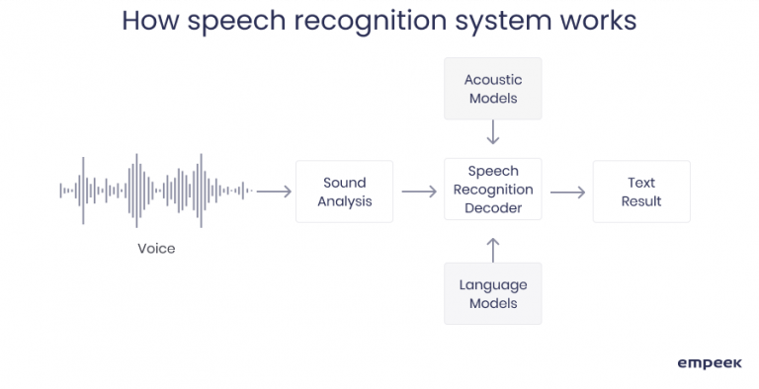

Fig 6.1 How Speech Recognition works

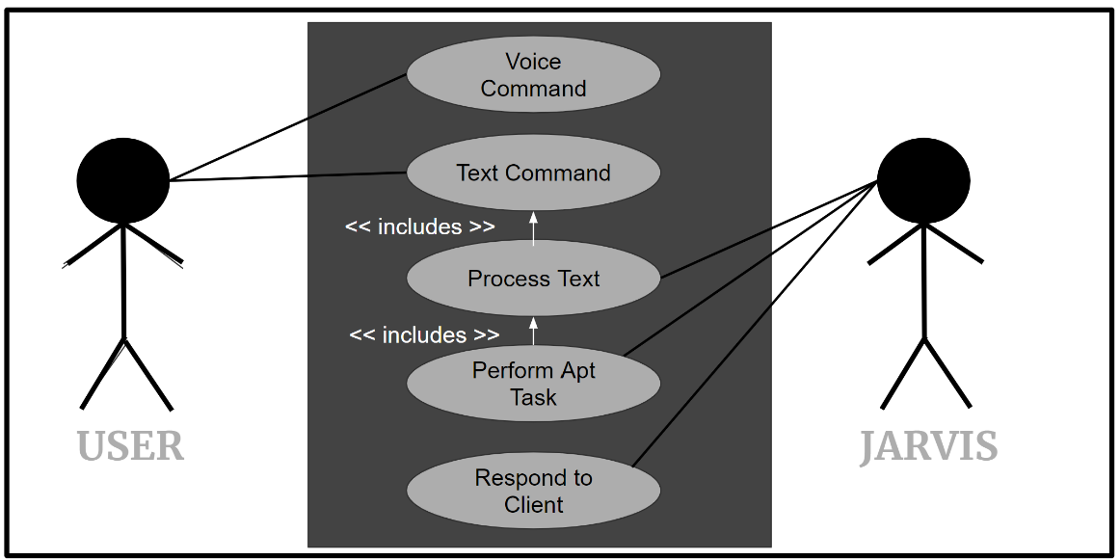

Fig 6.2 Use Case Diagram

In Python, speech recognition is commonly implemented using the `SpeechRecognition` library, which provides a simple interface for converting speech into text. The primary functions include `recognize_google()` for recognizing speech using the Google Web Speech API, `recognize_sphinx()` for offline recognition using CMU Sphinx, and `recognize_ibm()` for IBM Speech to Text. The `Recognizer` class is the core of the library, providing methods such as `listen()` to capture audio from a microphone and `record()` to process audio files. Additional utilities like `AudioFile` are used to handle different audio file formats. These functions and classes together make it easy to integrate speech recognition capabilities into Python applications.

**Main Source code**

import speech_recognition as sr

import pyttsx3

import pywhatkit

import datetime

import wikipedia

import requests

from bs4 import BeautifulSoup

listener = sr.Recognizer()

machine = pyttsx3.init()

#speaks the given command using the pyttsx3 engine.

def talk (text):

machine.say(text) #the text to be spoken.

machine.runAndWait()

#Listen to the user's voice instruction and return the text.

def input_instruction():

global instruction

try:

with sr.Microphone() as origin:

print("Hi,I am mvel, please tell me how may i help you")

talk('listening')

speech = listener.listen(origin)

instruction = listener.recognize_google(speech)

instruction = instruction.lower()

if "mvel" in instruction:

instruction = instruction.replace('mvel'," ")

print(instruction) #returns the user's voice instruction as text.

return instruction

except sr.UnknownValueError:

#returns an error voice if not heard the instruction properly.

print("Sorry, I didn't understand that")

return ""

except sr.RequestError as e:

print("Error; {0}".format(e))

return ""

#gets the current temperature of the given city.

def temperature():

city = instruction.split("in",1)[1]

url = f"https://www.google.com/search?q=weather+in+{city}"

soup = BeautifulSoup(requests.get(url).text, "html.parser")

region = soup.find("span", class_="BNeawe tAd8D AP7Wnd")

temp = soup.find_all("div", class_="BNeawe iBp4i AP7Wnd")

day = soup.find("div", class_="BNeawe tAd8D AP7Wnd")

weather = day.text.split("C", 1)

Temperature = temp[0].text.split("C", 1)

talk(f"its currently {weather[0]} and {Temperature[0]} celcius in {region.text}")

print(f"its currently {weather[0]} and {Temperature[0]} celcius in {region.text}")

#The main loop of the MVEL AI assistant.

def play_mvel():

while True:

instruction = input_instruction()

print(instruction)

#plays songs or videos from youttube.

if 'play' in instruction:

song = instruction.replace('play',"")

talk("playing" + song)

pywhatkit.playonyt(song)

#tells the time.

elif 'time' in instruction:

time = datetime.datetime.now().strftime('%I:%M%p')

talk('Current time' + time)

print('Current time' + time)

#tells the current date.

elif 'date' in instruction:

date = datetime.datetime.now().strftime('%d /%m /%Y')

talk("Toady's date" + date)

print("Toady's date" + date)

elif 'how are you' in instruction:

talk("I am fine, how you doing?")

print("I am fine, how you doing?")

elif 'what is your name' in instruction:

talk("I am mvel, What can i do for you")

print("I am mvel, What can i do for you")

elif 'hello' in instruction :

talk("hey hachu")

print("hey hachu")

elif 'how was your day' in instruction:

talk("good, how was yours")

print("good, how was yours")

#searches for information from wikipedia.

elif 'who is' in instruction:

people = instruction.replace('who is', "")

try:

information = wikipedia.summary(people, 1)

print(information)

talk(information)

except Exception as e:

talk("error finding information")

elif 'what is' in instruction:

people = instruction.replace('what is', "")

try:

information = wikipedia.summary(people, 1)

print(information)

talk(information)

except Exception as e:

talk("error finding information, be more specific")

#calls the weather function to return current weather at any city.

elif 'weather in' in instruction:

temperature()

#exception command.

else:

talk("Please repeate yourself")

print("Please repeate yourself")

play_mvel()

**Snapshots**

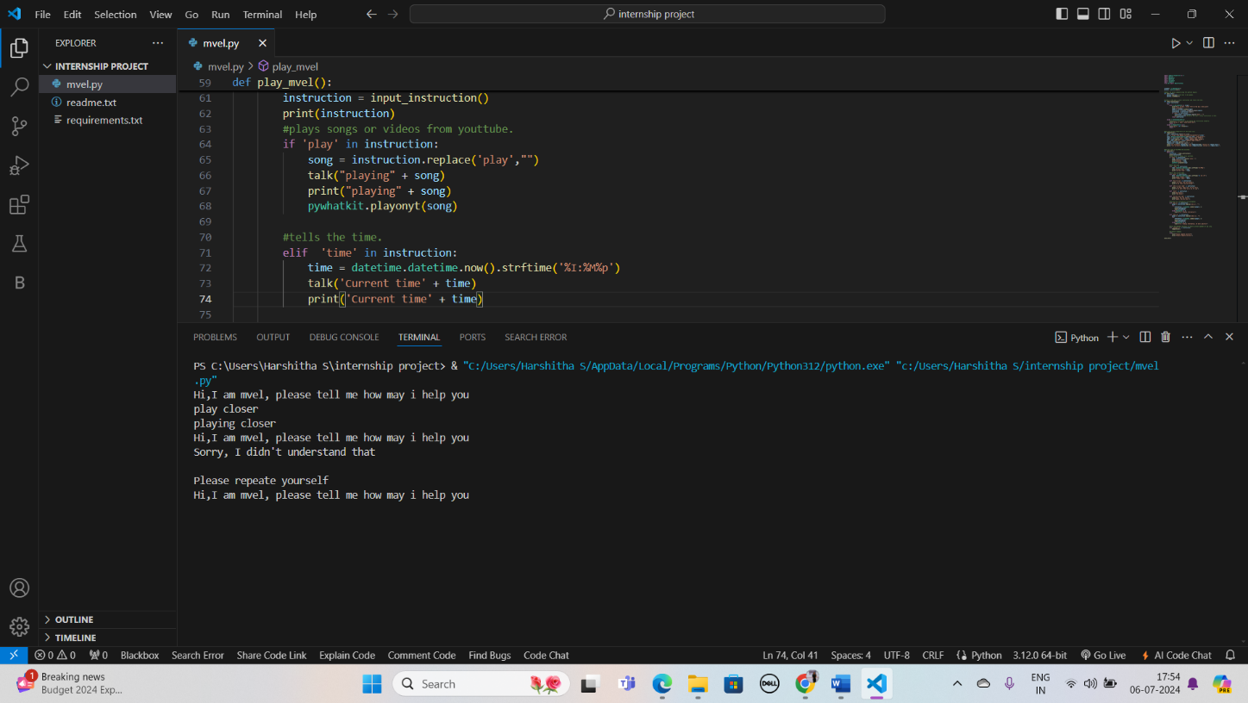

Fig 6.3 Playing function

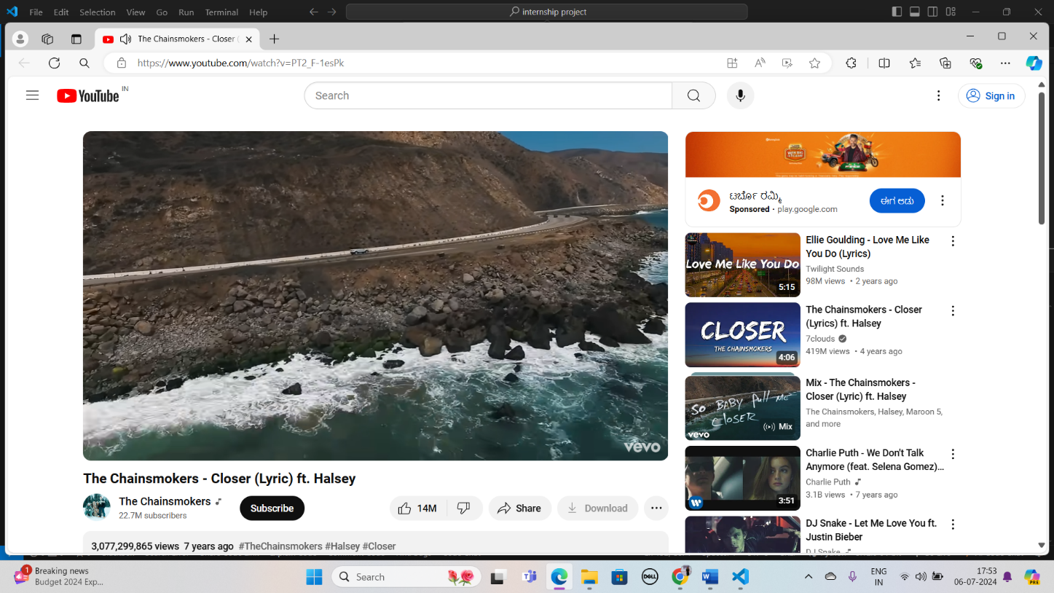

Fig 6.4 Playing the instruction

# 

# Fig 6.5 wikipedia function

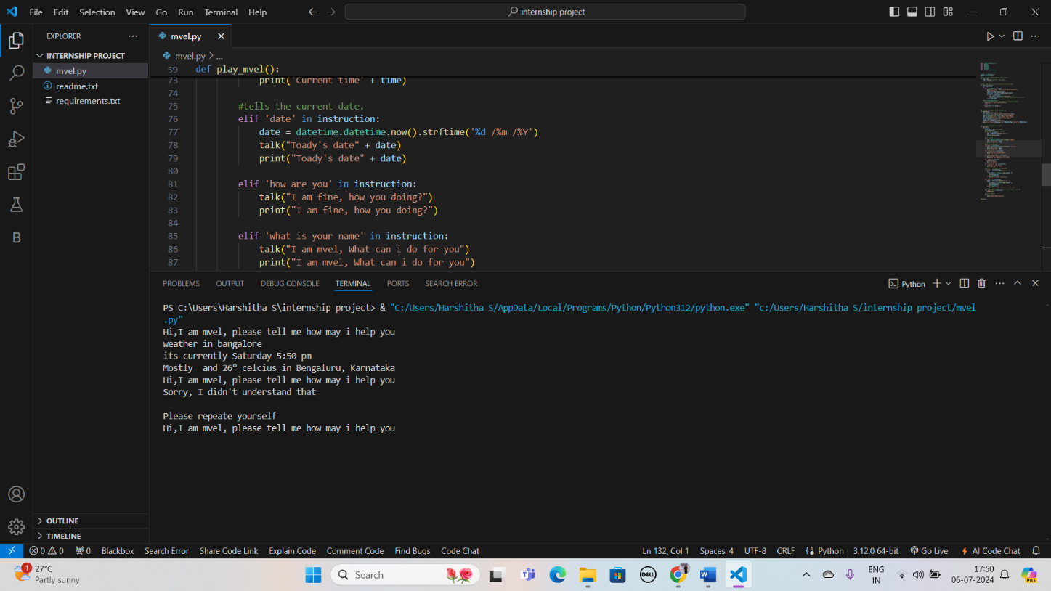

Fig 6.6 weather function

# CONCLUSION

The proposed system developed is capable of detecting voice of the user and analyse the input instruction and delivery the answer in a short time. In summary the virtual assistant MVEL, uses Python's SpeechRecognition library, in conjunction with other tools like pyttsx3 for text-to-speech, to facilitates the development of speech recognition and voice-controlled applications which uses the recognize_google() function from the SpeechRecognition library to interpret voice commands and performs various tasks such as fetching weather information, querying Wikipedia, and telling the time and date. These functions are pivotal in building interactive and responsive applications for visually impaired or blind people to make their daily life much easier and smoother. MVEL typically aims Automation of the entire system improves the efficiency and gives appropriate access to the authorized users depending on their permissions. It effectively overcomes the delay in communications, Updating of information becomes so easier. System security, data security and reliability are the striking features.

**REFERENCES**

* Marcos Barata, Afan Galih Salman, Ikhtiar Faahakhododo, Bayu Kanigoro,"Android based voice assistant for blind people", Library Hi Tech News, Vol. 35 Issue: 6, pp.9-11 (2018).
* DR. Kavitha C, MR. Nithin V Gopal, MS. Nidhi Amarnath, MR. Prajwal G, MS. Supreetha R.R., “VIRTUAL ASSISTANT FOR BLIND PEOPLE” (2018).
* Prof. Priya U. Thakare, Kote Shubham, Pawale Ankit, Rajguru Ajinkya, Shelke Om, “Smart Assistance System for the Visually Impaired” International Journal of Scientific and Research Publications, Volume 7, Issue 12, December 2017 378 ISSN 2250-3153 (2017).
* Analysis of Navigation Assistants for Blind and Visually Impaired People: A Systematic Review Sulaiman Khan, Shah Nazir, Habib Ullah Khan Year: 2021 , Volume: 9, Journal Article, Publisher: IEEE